CHAPTER THREE
METHODOLOGY AND SYSTEM DESIGN
3.1 Introduction
This chapter presents the methodology and system design adopted for the development of the SIWES Quality, Organization Vetting and Rating System (BUK-SIWES QOVRS). The chapter describes the project workflow, the software development model selected for the project, the analysis of the existing system, the requirement elicitation process, the requirements definition and analysis, and the design of the proposed system.
The chapter is organized to progressively establish the system requirements and translate them into a structured design. It begins with the project workflow, which outlines the complete sequence of activities from organization submission to future placement decisions. It then presents the system development model adopted for the project and explains how the project activities map to its phases. The analysis of the existing system establishes the current process and the problems that motivate the proposed system. The requirement elicitation section describes how the system requirements were obtained, and the requirements definition section presents the functional and non-functional requirements. The requirement analysis section uses use case diagrams and descriptions to model the system's interaction with its actors. Finally, the system design section presents the proposed system, its architecture, and its database design.
3.2 Project Workflow
The BUK-SIWES QOVRS is designed around a continuous quality-control workflow that connects pre-placement organization vetting with post-placement organization rating and review. The workflow consists of the stages described below.
Stage 1: Organization Submission
An organization submits its details and proposed SIWES training opportunity through the system. The information submitted includes the organization's name, address, industry or business area, the services it provides, and the specific training role or opportunity being proposed for students. The organization may also provide additional information relevant to the assessment of its suitability.
Stage 2: Departmental Vetting
The department, through the SIWES coordinator, reviews the submitted organization information. The review considers factors such as the relevance of the organization's core business to the student's course of study, the suitability of the proposed training role, and the capacity of the organization to provide meaningful practical exposure. Where the organization has an existing record in the system from previous placements, its accumulated rating and history are also considered during the vetting process.
Stage 3: Approval or Rejection
Based on the outcome of the vetting process, the department approves or rejects the organization. Only approved organizations become available for student placement requests. Rejected organizations are not added to the approved organization directory.
Stage 4: Approved Organization Directory
Approved organizations are maintained in an approved organization directory. This directory serves as the pool of organizations from which students can request SIWES placement. Organizations that have been blacklisted following departmental review are removed from the directory and are not available for new placement requests.
Stage 5: Student Placement Request
A student browses the approved organization directory and submits a placement request to an organization of interest. The system prevents students from requesting placement from organizations that have not been approved or that have been blacklisted. The student can view the status of their placement request through the system.
Stage 6: Placement
The student undertakes the SIWES placement with the organization. The placement is recorded in the system.
Stage 7: Placement Completion
After the student completes the SIWES placement, the placement is marked as completed in the system. This triggers the post-placement assessment process, and the relevant academic supervisor becomes responsible for completing the assessment.
Stage 8: Academic Supervisor Assessment
The assigned academic supervisor completes a structured assessment of the organization based on the student's completed placement. The assessment covers dimensions such as the relevance of the skills and training acquired, the adequacy of supervision provided by the organization, the alignment of the training with the student's curriculum, and the overall quality of the training experience. The assessment includes a rating that contributes to the organization's quality record.
Stage 9: Organization Rating and History
The supervisor's assessment contributes to the organization's running rating and quality history. The system maintains a record of all assessments associated with each organization, allowing the organization's quality record to accumulate over time. The exact method for aggregating individual assessments into an organization-level rating is a design decision that will be finalized during detailed system design and implementation.
Stage 10: Low-Rating Flag
When an organization's rating meets the defined low-rating condition, the system automatically flags the organization for departmental attention. The flag indicates that the organization requires review; it does not by itself change the organization's status or remove it from the approved directory.
Stage 11: Departmental Review
The department reviews the flagged organization. The review considers the organization's assessment history, the nature of the concerns raised, and any other relevant information. Possible outcomes of the review include retaining the organization's approval, placing the organization under monitoring, requiring further assessment, or removing the organization from future placement consideration through blacklisting.
Stage 12: Future Placement Decision
The outcome of the departmental review and the organization's accumulated quality history become part of the information available to support future placement decisions. Organizations with strong records can continue to be available for placement, while organizations that have been blacklisted are excluded from the approved directory.
The workflow of the proposed system is presented in Figure 3.1.
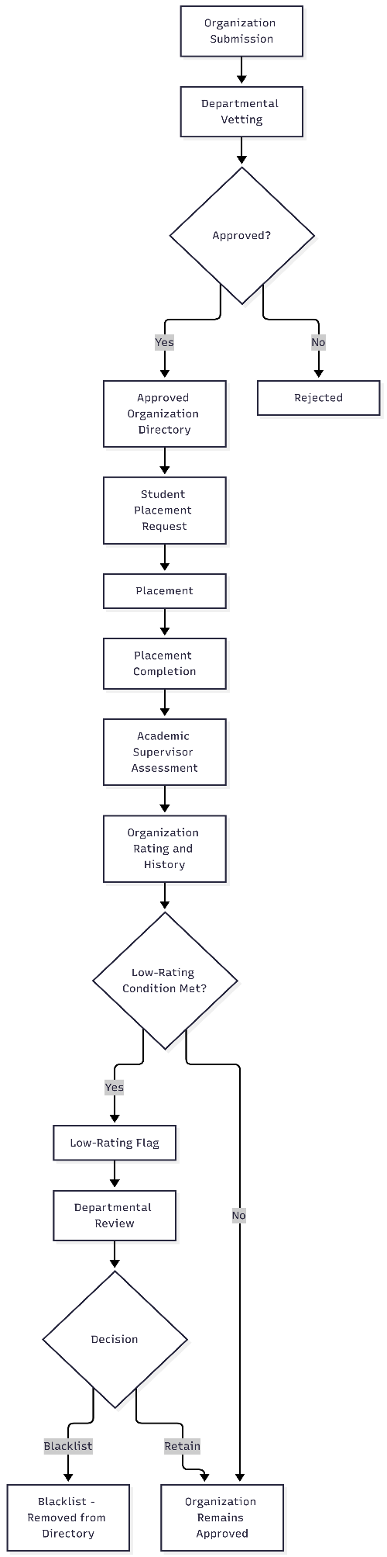
Figure 3.1: Project Workflow of the Proposed BUK-SIWES QOVRS
3.3 System Development Model
The development of the BUK-SIWES QOVRS follows an iterative and incremental approach, which is consistent with the principles of the Agile development methodology. The Agile methodology is selected for this project because it supports progressive refinement of requirements, iterative design and development, and continuous improvement based on feedback. These characteristics are well suited to a project in which the requirements are progressively clarified through stakeholder consultation and in which the system design evolves as understanding of the problem deepens.
The Agile methodology is organized around short development iterations, each of which produces a working increment of the system. For the BUK-SIWES QOVRS, the project activities are mapped to the following phases across the development iterations:
Requirements Gathering: The requirements for the system are gathered through consultation with SIWES coordinators, academic supervisors, and students, as well as through review of the project specification and the literature. The requirements are documented and refined as the project progresses.
System Analysis: The gathered requirements are analyzed to identify the system's actors, use cases, and functional and non-functional requirements. This phase also involves analysis of the existing process to identify the problems the system must address.
Design: The system architecture, database structure, and user interface designs are developed based on the analyzed requirements. The design is refined iteratively as new requirements or design considerations emerge.
Implementation: The system is implemented in increments, with each increment delivering a working set of features. The implementation is guided by the design and is tested as it is developed.
Testing: Each increment is tested to verify that it meets the specified requirements and functions correctly. Testing includes unit testing of individual components and integration testing of the system as a whole.
Feedback and Refinement: Feedback obtained during testing and review is used to refine the system in subsequent iterations. This allows the system to be improved progressively throughout the development process.
The Agile methodology is appropriate for this project because it accommodates the iterative nature of requirements elicitation and design refinement, allows for continuous testing and improvement, and supports the progressive delivery of system functionality. It is also consistent with the academic context of the project, in which the system is developed and refined over the course of the project period.
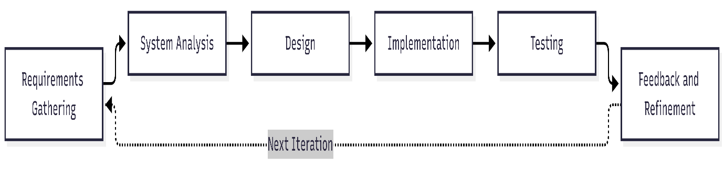Figure 3.2: Software Development Model Adopted for the Project

3.4 Analysis of Existing and Proposed System
This section presents the analysis of the existing SIWES organization placement and management process, the requirement elicitation process, the requirements definition, and the requirement analysis.
3.4.1 Existing System
The existing SIWES organization placement and management process, as established during the requirement elicitation for this project, is characterized by a largely manual and fragmented approach to organization selection, placement, and post-placement assessment. Based on the requirement elicitation conducted for this project, the process typically involves students identifying potential placement organizations independently and submitting the necessary documentation to the department for administrative processing. The department maintains records of placements, but there is no structured mechanism for systematically evaluating the suitability of organizations before placement or for capturing and aggregating post-placement assessments at the organization level.
The literature reviewed in Chapter Two established that existing SIWES and internship management systems generally focus on administrative functions such as placement allocation, logbook management, monitoring, and student assessment, and that organization-level vetting and rating mechanisms are not commonly reported in the reviewed systems. This finding is consistent with the observations from the requirement elicitation, which indicated that the existing process does not include a structured mechanism for evaluating organizations before placement or for maintaining an organization-level quality record that can inform future placement decisions.
The limitations of the existing process, as established through the requirement elicitation, include the following: there is no structured vetting of organizations before students are placed with them; there is no systematic mechanism for recording and aggregating supervisor assessments at the organization level; there is no organization-level quality history that can be used to inform future placement decisions; and there is no mechanism for identifying organizations that consistently provide poor-quality training and for reviewing their continued suitability for placement.
The existing process for SIWES organization placement is illustrated in Figure 3.3.
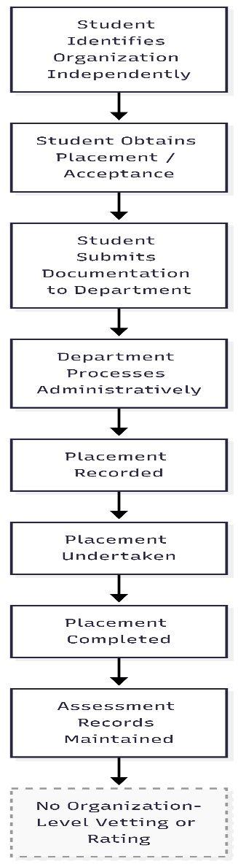
Figure 3.3: Existing Process for SIWES Organization Placement
3.4.2 Requirement Elicitation
The requirements for the BUK-SIWES QOVRS were elicited through consultation with stakeholders involved in the SIWES process and through review of the project specification and relevant literature. The elicitation focused on understanding the current process, identifying its limitations, and determining the requirements for a system that would address the identified problems.
The stakeholders consulted during the elicitation included the SIWES coordinator, who is responsible for managing the SIWES process at the departmental level; academic supervisors, who supervise students during and after their placements; and students, who participate in SIWES placements. The elicitation explored the current process for organization selection and placement, the challenges encountered in managing organization quality, and the requirements for a system that would support organization vetting, placement management, and post-placement assessment.
Table 3.1: Summary of Requirement Elicitation Findings
Stakeholder | Need/Problem Identified | System Requirement
SIWES Coordinator | No structured mechanism for vetting organizations before placement; difficulty in tracking organization quality over time | Organization submission and vetting workflow; approved organization directory; organization history and rating
Academic Supervisor | No structured mechanism for recording post-placement assessments at the organization level; assessments are not aggregated to inform future decisions | Supervisor assessment module; organization-level rating and history
Student | Difficulty in identifying suitable organizations; limited information about organization quality | Approved organization directory; ability to view
Organization | No structured channel for submitting organization information and proposed training opportunities | Organization registration and submission module
The full requirement elicitation instrument and evidence are provided in the Appendix.
3.4.3 Requirements Definition
The requirements for the BUK-SIWES QOVRS are defined in terms of functional requirements and non-functional requirements.
Functional Requirements
The functional requirements describe the functions that the system must perform to meet the needs of its stakeholders.
Organization Requirements:
- The system shall allow an organization to submit its details, including name, address, industry/business area, services provided, and proposed training role.
- The system shall allow an organization to view the status of its submission.
Department/SIWES Coordinator Requirements:
- The system shall allow the SIWES coordinator to review submitted organization information.
- The system shall allow the SIWES coordinator to approve or reject an organization based on the relevance of its business area, the suitability of the proposed training role, and any existing organizational history.
- The system shall maintain an approved organization directory containing all approved organizations.
- The system shall allow the SIWES coordinator to view the assessment history and rating of any organization in the system.
- The system shall automatically flag organizations that meet the defined low-rating condition for departmental review.
- The system shall allow the SIWES coordinator to review flagged organizations and decide whether to retain the organization's approval or blacklist the organization from future placement consideration.
- The system shall allow the SIWES coordinator to manage placement requests, including viewing and processing student placement requests.
Student Requirements:
- The system shall allow a student to view the approved organization directory.
- The system shall allow a student to submit a placement request to an approved organization.
- The system shall prevent a student from submitting a placement request to an organization that is not approved or that has been blacklisted.
- The system shall allow a student to view the status of their placement request.
Academic Supervisor Requirements:
- The system shall allow an academic supervisor to view completed placements assigned to them.
- The system shall allow an academic supervisor to submit a structured assessment of an organization based on a completed placement.
- The system shall allow an academic supervisor to provide a rating as part of the assessment.
System Requirements:
- The system shall maintain records of organizations, placements, assessments, and ratings.
- The system shall update the organization's rating and history when a new assessment is submitted.
- The system shall maintain organization status and prevent placement requests to blacklisted organizations.
- The system shall provide appropriate access control based on user roles.
Non-Functional Requirements
The non-functional requirements describe the quality attributes that the system must exhibit.
Usability: The system shall provide a user-friendly interface that allows users to perform their tasks efficiently without extensive training.
Security: The system shall implement role-based access control to ensure that only authorized users can access and modify system data. User authentication shall be required for all system access.
Reliability: The system shall be reliable and shall handle concurrent user access without data loss or corruption. The system shall include mechanisms for data backup and recovery.
Performance: The system shall respond to user requests within an acceptable time frame under normal operating conditions.
Maintainability: The system shall be designed in a modular manner to facilitate maintenance and future enhancements.
Data Integrity: The system shall ensure the accuracy and consistency of data stored in the database, including the correct association of assessments with organizations and placements.
3.4.4 Requirement Analysis
The requirement analysis for the BUK-SIWES QOVRS is presented using a use case diagram and use case descriptions. The use case diagram identifies the system's actors and their interactions with the system, while the use case descriptions provide detailed explanations of the major use cases.
Actors
The actors in the BUK-SIWES QOVRS are:
Organization: An entity that submits organization information and proposed training opportunities for departmental vetting.
Student: A student who views approved organizations, submits placement requests, and views placement status.
Academic Supervisor: A supervisor who assesses completed placements and provides organization ratings.
SIWES Coordinator: The departmental administrator responsible for reviewing organizations, managing the approved organization directory, reviewing flagged organizations, and managing placement requests.
The use case diagram of the proposed system is presented in Figure 3.4.
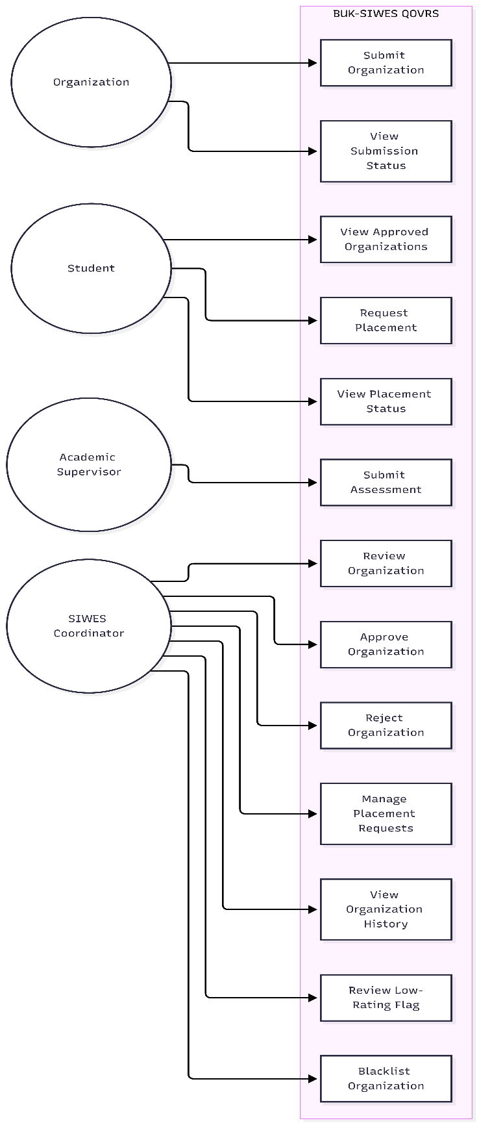
Figure 3.4: Use Case Diagram of the Proposed BUK-SIWES QOVRS
Use Case Descriptions
Table 3.2: Use Case Descriptions
Use Case | Actor | Description
Submit Organization | Organization | The organization submits its details and proposed training role for departmental vetting.
View Submission Status | Organization | The organization views the status of its submission (pending, approved, or rejected).
Review Organization | SIWES Coordinator | The coordinator reviews the submitted organization information and assesses its suitability.
Approve Organization | SIWES Coordinator | The coordinator approves the organization, adding it to the approved organization directory.
Reject Organization | SIWES Coordinator | The coordinator rejects the organization, preventing it from being available for placement.
View Approved Organizations | Student | The student views the list of approved organizations available for placement.
Request Placement | Student | The student submits a placement request to an approved organization.
View Placement Status | Student | The student views the status of their placement request.
Manage Placement Requests | SIWES Coordinator | The coordinator views and processes student placement requests.
Submit Assessment | Academic Supervisor | The supervisor submits a structured assessment of the organization based on a completed placement.
View Organization History | SIWES Coordinator | The coordinator views the assessment history and rating of an organization.
Review Low-Rating Flag | SIWES Coordinator | The coordinator reviews organizations flagged for low ratings and decides on appropriate action.
Blacklist Organization | SIWES Coordinator | The coordinator removes an organization from the approved directory following a review.

Activity Diagram
The activity diagram represents the workflow of organization vetting and placement, showing the sequence of activities from organization submission to placement request.
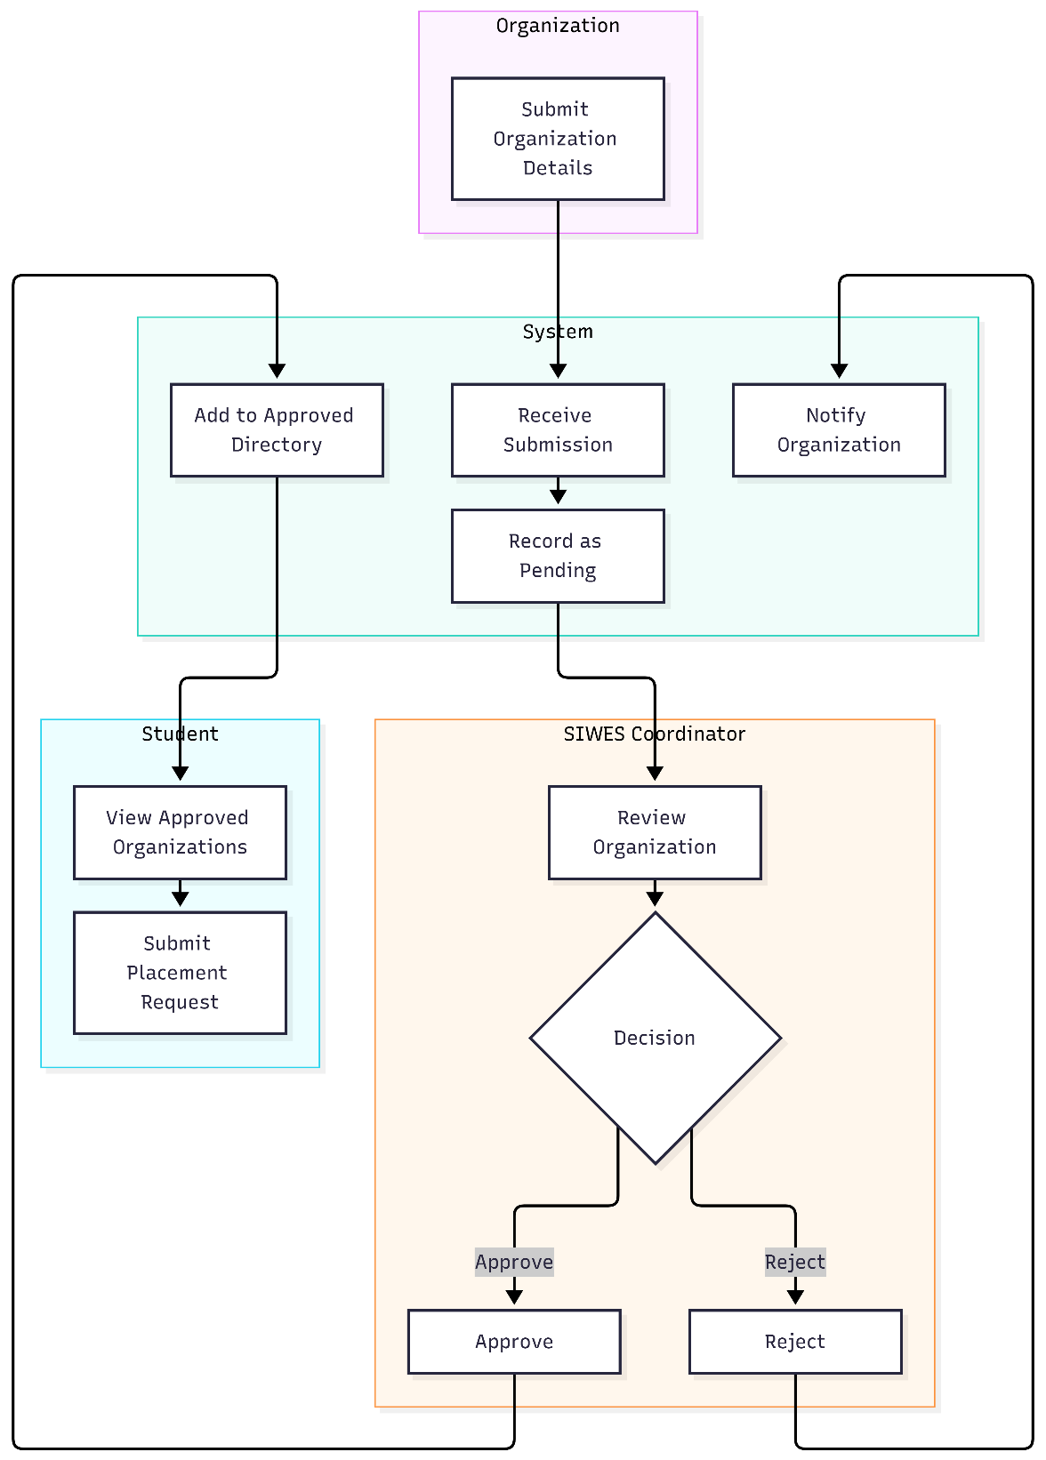
Figure 3.5: Activity Diagram of the Organization Vetting and Placement Workflow

Sequence Diagram
The sequence diagram represents the interactions between the SIWES coordinator, the system, and the organization during the vetting and approval process.
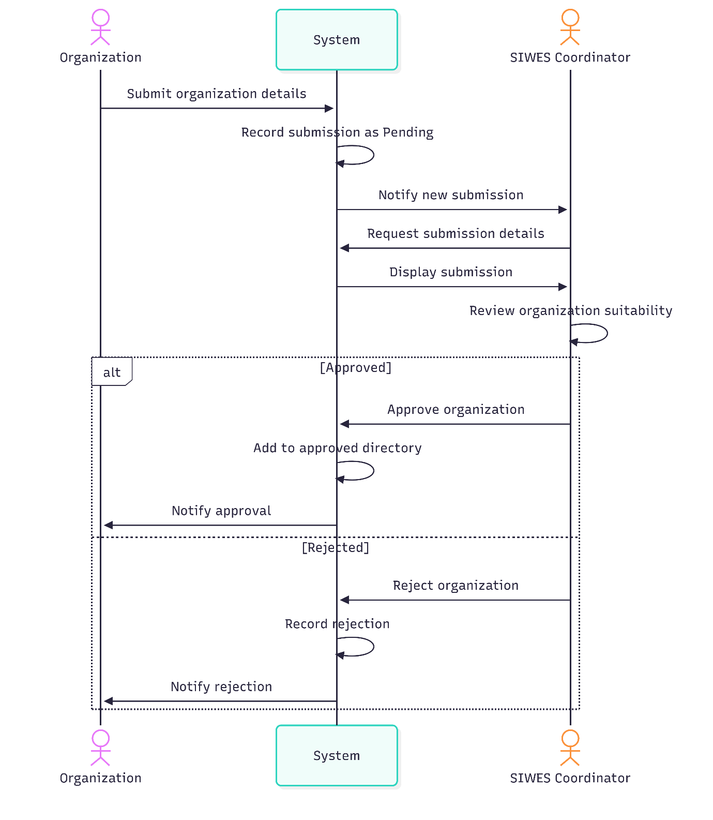
Figure 3.6: Sequence Diagram for Organization Vetting and Approval

State Diagram
The state diagram represents the possible states of an organization within the system and the transitions between those states. The states include Submitted, Under Review, Approved, Rejected, Active, Flagged, Reviewed, and Blacklisted. The transition from Flagged to Blacklisted occurs only after departmental review and decision.
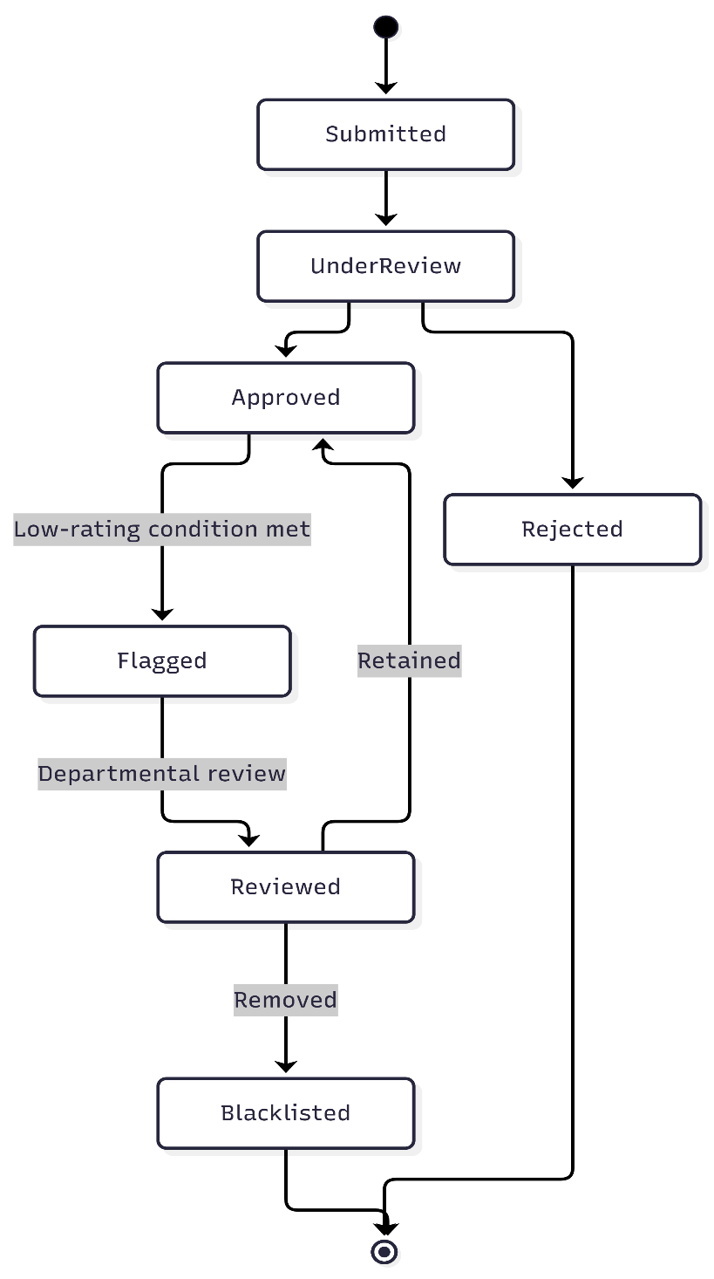
Figure 3.7: State Diagram of Organization Status

3.5 System Design
This section presents the design of the proposed BUK-SIWES QOVRS, including the description of the proposed system, the architecture design, and the database design.
3.5.1 Proposed System
The proposed BUK-SIWES QOVRS is a web-based system designed to provide a continuous quality-control process for SIWES placements. The system addresses the limitations of the existing process by providing a structured mechanism for vetting organizations before placement, maintaining an approved organization directory, capturing post-placement assessments, aggregating assessments into organization-level ratings, flagging low-rated organizations for departmental review, and supporting departmental decisions regarding blacklisting.
The proposed system aims to reduce the likelihood of students being placed with organizations that are unsuitable or that provide poor-quality training. It also aims to provide the department with the information needed to make better placement decisions and to continuously improve the quality of SIWES placements over time. The system does not claim to eliminate all poor placements; rather, it provides a structured mechanism for systematically evaluating and improving organization quality.
The proposed system supports the following core functions:
- Organization registration and submission;
- Departmental vetting and approval/rejection;
- Approved organization directory management;
- Student placement requests;
- Post-placement supervisor assessment;
- Organization rating and history maintenance;
- Low-rating flagging;
- Departmental review of flagged organizations;
- Blacklisting and removal from the approved directory;
- Support for future placement decisions based on organization history.
3.5.2 Architecture Design
The BUK-SIWES QOVRS is designed using a layered web architecture, which is appropriate for a web-based information system of this scope. The architecture consists of the following layers:
Presentation Layer: The presentation layer provides the user interface through which users interact with the system. It is responsible for displaying information and capturing user input. The presentation layer is designed to be accessible through standard web browsers and provides role-specific interfaces for organizations, students, academic supervisors, and the SIWES coordinator.
Application/Business Logic Layer: The application layer contains the business logic of the system. It processes user requests, applies business rules, and coordinates the flow of data between the presentation layer and the data layer. This layer implements the core functionality of the system, including organization vetting, placement request processing, assessment submission, rating calculation, and flagging logic.
Data Access Layer: The data access layer provides an abstraction between the application logic and the database. It handles database queries and updates, ensuring that data is accessed and modified consistently.
Database Layer: The database layer stores all system data, including user accounts, organization records, placement requests, assessments, ratings, and organizational history. The database is designed to support the complete workflow of the system.
The architecture of the proposed system is presented in Figure 3.8.
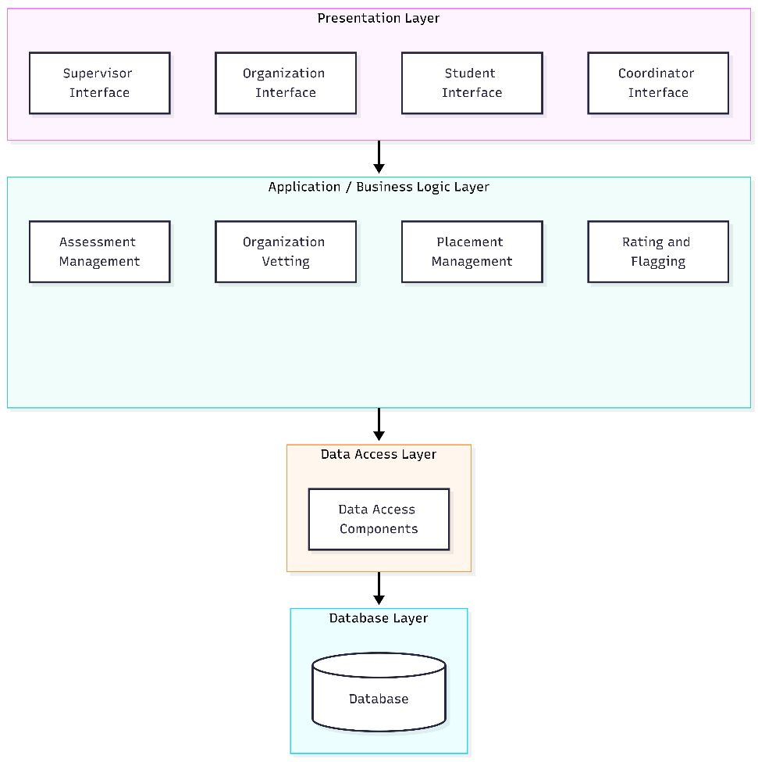
Figure 3.8: Architecture of the Proposed BUK-SIWES QOVRS
Class/Package Diagram
The class/package diagram represents the major components of the system and their relationships. The diagram identifies the key entities and modules that make up the system.
The class/package structure of the proposed system is presented in Figure 3.9.
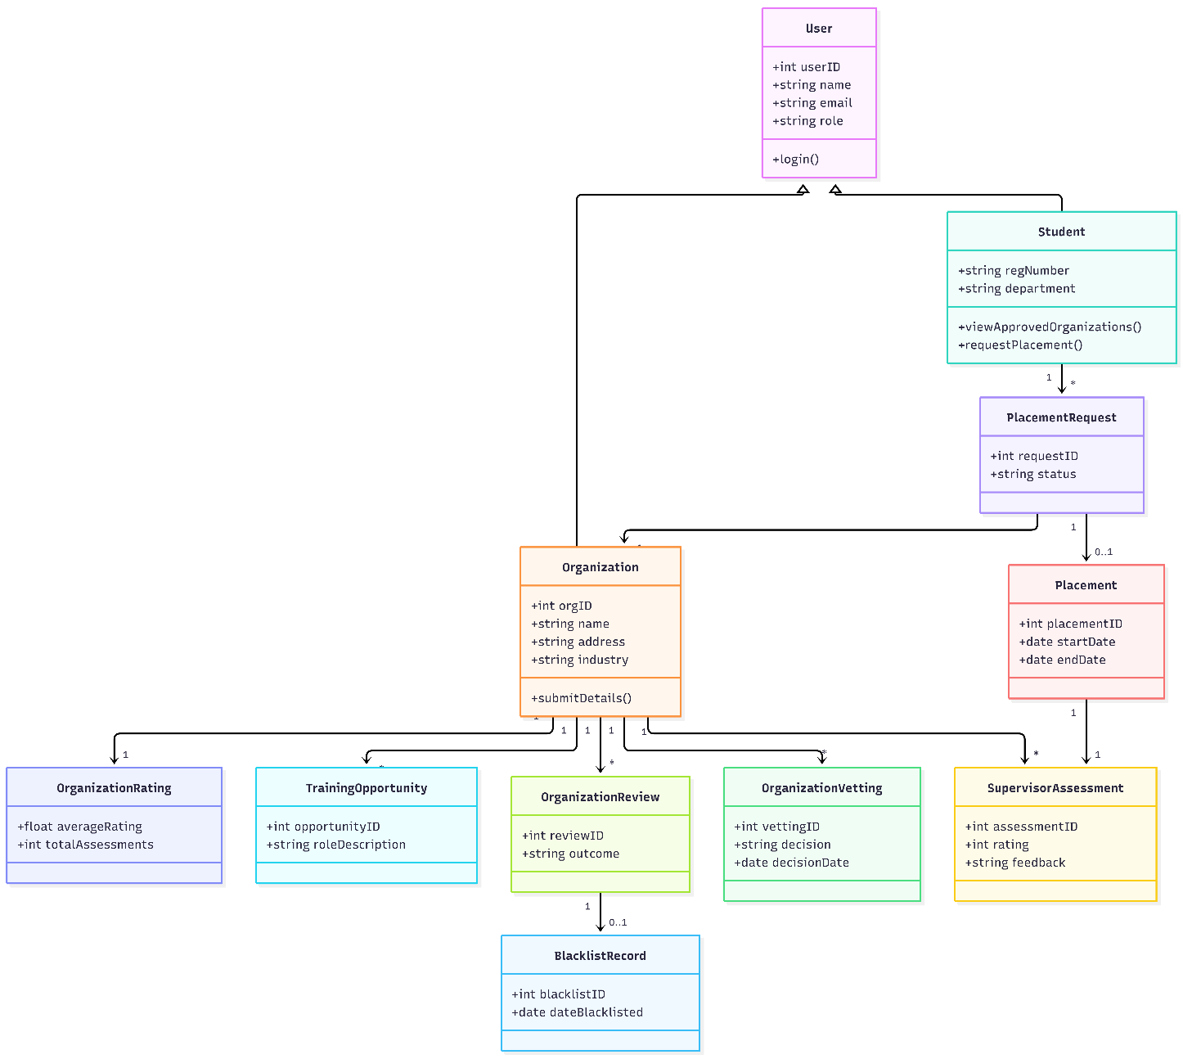
Figure 3.9: Class/Package Structure of the Proposed BUK-SIWES QOVRS
3.5.3 Database Design
The database for the BUK-SIWES QOVRS is designed to support the complete workflow of the system, from organization submission through to post-placement assessment and organization rating. The database consists of the major entities described below.
User: Stores information about all users of the system, including students, academic supervisors, SIWES coordinators, and organization representatives. The user entity includes authentication information and role designation.
Student: Stores additional information about students, including their registration number, department, and course of study.
Organization: Stores information about organizations that submit for vetting, including name, address, industry/business area, services provided, and contact information.
Training Opportunity: Stores information about the training role or opportunity proposed by an organization, including a description of the role and its relevance to the student's course of study.
Organization Vetting: Stores the outcome of the departmental vetting process, including the vetting decision, the date of the decision, and any comments provided by the SIWES coordinator.
Placement Request: Stores student placement requests, including the student, the organization requested, the date of the request, and the status of the request.
Placement: Stores information about completed placements, including the student, the organization, the start and end dates, and the completion status.
Supervisor Assessment: Stores the structured assessment submitted by the academic supervisor, including the assessment criteria responses and the overall rating.
Organization Rating: Stores the aggregated rating for each organization, calculated from the assessments submitted by academic supervisors.
Organization Review/Flag: Stores information about organizations that have been flagged for departmental review, including the reason for the flag, the date of the flag, and the outcome of the review.
Blacklist Record: Stores information about organizations that have been blacklisted, including the date of blacklisting and the reason for the decision.
Table 3.3: Database Entity Descriptions
Entity | Purpose
User | Stores authentication and role information for all system users.
Student | Stores student-specific information.
Organization | Stores organization details submitted for vetting.
Training Opportunity | Stores information about proposed training roles.
Organization Vetting | Stores vetting decisions and related information.
Placement Request | Stores student placement requests and their status.
Placement | Stores completed placement information.
Supervisor Assessment | Stores supervisor assessments of organizations.
Organization Rating | Stores aggregated ratings for each organization.
Organization Review/Flag | Stores information about flagged organizations.
Blacklist Record | Stores information about blacklisted organizations.

The entity relationship diagram of the proposed system is presented in Figure 3.10.
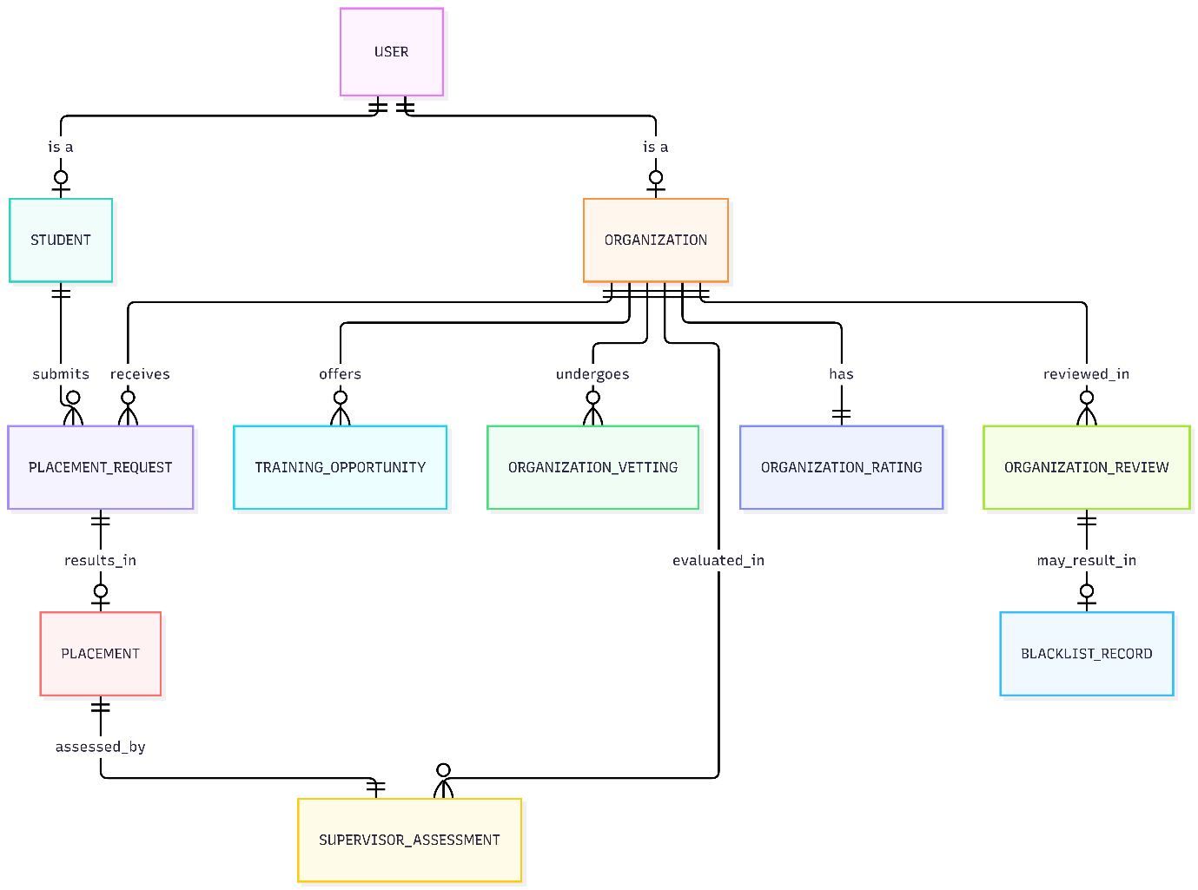
Figure 3.10: Entity Relationship Diagram of the Proposed BUK-SIWES QOVRS

3.6 Summary
This chapter has presented the methodology and system design for the BUK-SIWES QOVRS. The chapter described the project workflow, which connects pre-placement organization vetting with post-placement organization rating and review in a continuous quality-control cycle. The Agile development methodology was selected for the project, and the project activities were mapped to its phases. The analysis of the existing system established the limitations of the current process, and the requirement elicitation described how the system requirements were obtained from stakeholders. The requirements definition presented the functional and non-functional requirements for the system, and the requirement analysis used use case diagrams and descriptions to model the system's interactions with its actors. The system design section presented the proposed system, its layered architecture, and its database design. The next chapter will present the implementation and testing of the proposed system.

